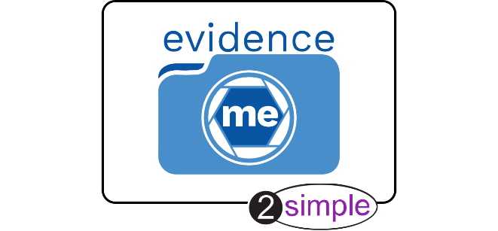

Dear Parent/Carer,

We’ve started to use a new system which will allows us to share what your child is doing in school.
The ‘Parent Share’ feature in Evidence Me enables you to view your child’s observations (complete with photos and/or videos) via the app or web suite, showing you what your child has been learning and the new skills they are developing.
We think these will really brighten up your day!
You can send us your comments and feedback by simply adding them to the observations via the app or web suite. This will help our staff to support your child even more effectively in the classroom.
You can also take an active role in contributing to your child’s observation portfolio by uploading your own observations, simply add these to the app or web suite.

You will receive an email in the next few days from donotreply@evidence.me asking you to confirm that you would like to participate. Make sure you check your spam/junk inbox as sometimes emails can get lost in there.
Participation is optional, but we really recommend getting involved. If you have any questions or need any additional information, please contact the school directly.
We look forward to supporting you and your child and are always striving to provide the highest standard of education possible.
Please visit http://help.evidence.me/evidence-me-help-for-parents/ for further information and guidance.

“Teachers and parents tend to be so busy that often you had to wait until parents evening to really find out what your child had been doing in school. But with Parent Share I get regular updates, complete with photos and comments from the teacher straight into my inbox. I think it’s wonderful and it has really helped me support my child’s learning at home. My husband and I love reading through the reports together in the evenings. I would really recommend it to other parents.”
Julie Greenwood, Parent, Camden

Evidence Me and Parent Share are provided by 2Simple Software.
You can find out more about 2Simple by visiting www.2simple.com

